Julianne Zimmerman

# Internship Goals

I hope to gain more knowledge than ever before through an internship, specifically in the world of digital marketing and web design. I aim to create for it is my passion. We interact through social media almost every single day, so why not create something that is not only visually appealing to the eye, but also enjoyable to use? I want to make an impact. I am hungy to explore the technicalities of a webpage, and why we are attracted to some things and not others. Ultimately, I am eager to see my work come to life in the real world. I enjoy creating layouts and wireframes for campaigns and websites and would love to learn more about the aesthetic side of the internet. The efficiency of a website is very important to me, so I wish to learn more about how a webpage impacts the consumer. Overall, I hope to gain a stronger sense of HTML and CSS.

## SKILLS

### Intermediate experience in Adobe Creative Cloud Illustrator and Premiere Pro

### Basic knowledge in Microsoft Word

### Efficient experience of the HTML and CSS language

### High communication and customer relation skills

# WORK EXAMPLES

### Throughout the past four to five months, I have created a series of work examples in my introduction to web design class.

Resource Recycling Conference Mockup (<http://heyobfamily.com/Jules/>)

### This practically fully functioning website is the latest work I have tackled. Each tab redirects you to a different and customized page.

### 

### 

Simply Snack Wireframes

Before creating any kind of website, a layout or wireframe is important to physically visualize how you want your product to be displayed. This wireframe was created using Adobe Illustrator.

### 

### Simply Snack Mockup

### When given the issue of nutrition surrounding college students, we were asked to create a kind of service that would eliminate some of those problems. Simply Snack is a fake company I created to deliver food right to the student door, as well as act as a place to log their calorie intake, water intake, and exercise.

# 

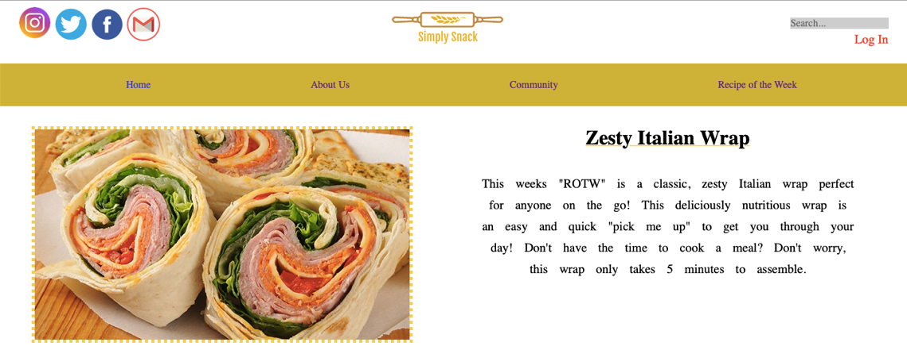



Visual Displays

After working at Nothing Bundt Cakes, I was taught how to create beautiful displays that would capture customers’ attention. I was also entrusted to see the retail.

